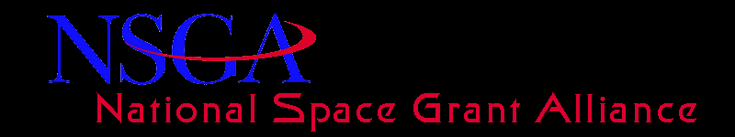
Minutes of the Alliance General Body Meeting (Washington DC) – February 26, 2014 at 8.00am Eastern
John Gregory commenced the meeting at 8:05am
The Alliance Secretary, Jaydeep Mukherjee, reminded the members that the minutes of the Fall General Body Meeting held in Charleston on October 14, 2013 were emailed to them last week. Peter Sukanek moved to approve the Charleston minutes. This motion was seconded by Majid Jaridi. All were in favor.
Toni Galvin presented the Treasurer’s report which included the income and expenditures for CY2013.
Leslee Gilbert from VSA and Joe Danek from TIG informed the members on the current issues.
The main points were as follows:
- FY 14 Omnibus (Leslee Gilbert)
  - Passed in January of 2014
  - Space Grant Appropriated at $40 million
  - Included the following language: “Any grant funds available in excess of the amount needed to fulfill base awards shall be made available to all consortia on a competitive basis.”
- Congressional Appropriations (Leslee Gilbert)
  - FY 2015 Congressional Budget already set
  - Flat budget for FY 2015
  - Budget Request for Space Grant
- NASA Reauthorization (Leslee Gilbert)
  - House Bill—Passed Science Committee in July 2013. Includes language supporting Space Grant.
  - Senate Bill—Passed Senate Commerce Committee in July 2013. Includes language on Space Grant.
  - Outlook for Final Passage
- Space Grant Financial Update (Joe Danek)
- Hill Visits & Folder Materials (Leslee Gilbert)
- Question & Answer
Jaydeep Mukherjee moved to adjourn the meeting at 9:20am. Edward Duke seconded the motion. All in favor.

