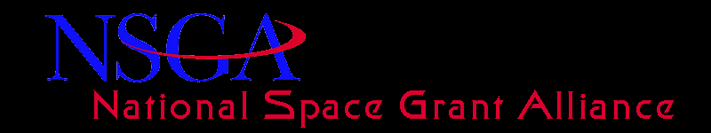
Minutes of the Alliance General Body Meeting (Washington DC) – February 25, 2015 at 8.00am Eastern
John Gregory commenced the meeting at 8:05am
Toni Galvin presented the Treasurer’s report which included the income and expenditures for CY2014.
Leslee Gilbert from VSA and Joe Danek from TIG informed the members on the current issues.
The main points were as follows:
- FY 2015 Omnibus
  - Passed in December of 2014
  - Space Grant Appropriated at $40 million
  - Included the following language: “Any grant funds available in excess of the amount needed to fulfill base awards shall be made available to all consortia on a competitive basis”

- FY 2016 Appropriations
  - FY 2016 President’s Budget Request - $24M
  - FY 2016 Congressional Strategy - $40M + language

- NASA Reauthorization
  - House bill was passed by the House in January and includes language supporting Space Grant
  - Senate Bill – Forthcoming
  - Outlook for final passage

- Hill Visits and Folder Materials
  - Overview of Folder Materials
    - Space Grant “Ask”
    - Sample Letters and Forms
    - Informational Materials
  - Strategies for Hill Visits
    - Member Support of Space Grant
    - Funding Support for the program

- SG Programmatic and Financial Update
  - Improved Relations with HQ
    - Regular Calls with Lenell – Steve Ruffin and Majid Jaridi
    - Meeting with Associate Administrator Mr. Donald James
    - Amended solicitation for 3. Yr Bridge Funding @27.45M for 3yr. bridge awards
    - Commitment to “NO Funding Gap”
    - SG Directors Engagement in Evaluation Plan
  - Remaining Challenges
    - Award/Timing of 3. Yr Bridge Awards
    - Use of Congressional Plus-up
    - Program Tax
    - Unallocated Appropriations

Meeting was adjourned at 9am.

