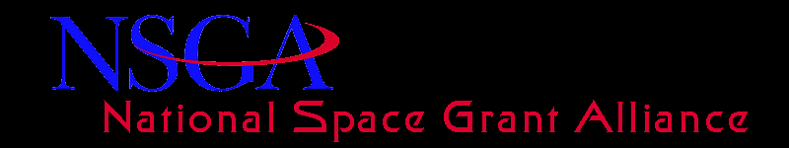
Minutes of the Alliance General Body Meeting (Grand Forks, ND) – September 15, 2017
Agenda:
Survey Results for Congressional Requests
FY 2018 Appropriations’ Outlook
Programmatic and Financial Update
Space Grant Data Update

John Kosmatka commenced the meeting at 4:15 pm
Survey Results for Congressional Requests

FY 2018 Appropriations’ Outlook
Where are we currently?
- Space Grant Authorized this Year
- FY 2018 President’s Budget Request
- FY 2018 Congressional Status Update
- Continuing Resolution (CR) until Dec.8 just signed by the President
- House and Senate FY18 Space Grant Language
- House FY18 CJS Bill
  - OE: $90M, a $10M reduction from FY17
  - SG: $40M, EPSCoR: $18M, MUREP: $32M
  - SG/OE Language: “The Committee understands that the Office of Education is undergoing a series of internal reviews and assessments; the Committee expects NASA to continue implementing the programs below and to ensure that overhead costs to support these programs do not exceed five percent. The recommendation includes $40M for the Space Grant program. This amount shall be allocated to State Consortia for competitively awarded grants in support of local, regional, and national STEM needs.”
- Senate CJS FY18 Bill
  - OE: $100M, SG: $40M, EPSCoR: $18M, MUREP: $32M, SEAP: $10M
  - SG/OE Language: “The Committee provides $40M for Space Grant and Directs NASA to support an extension of the current Space Grant program, and to allocate the entire funding amount for consortia-led institutions in all 52 participating jurisdictions according to the percentage allocation provided to States in the current 5-year grant award”
FY 2018 Appropriations What to Expect for the Future
December End Game Possibilities
- FY18 Omnibus
  - CR (long or short term
- Effect on Space Grant
  - Timing of release of funds
- Release of New 5-Year RFP
SG Programmatic and Financial Update
Improved Relations with HQ
- Regular calls with Lenell by Steve, Angela, and John continue
- Interactions with NASA Leaders:Deputy Adm. Lesa Roe; Mike Kincaid
- Full funding: Base + Augmentation @$36.3M for FY16 & FY17
- RFP released for 4th year with no gap
- Mike Kincaid attending National Council of SG Directors’ Annual Meeting
- OE cooperating with SG Data & Strategic Positioning Committee
- SG national leader in Eclipse
Current Challenges
- Timely processing of 4th year award
- Administrative tax approaching 5% cap
- Increase SG in President’s budget
- Increase SG visibility, within & outside of NASA
- Integrate but sustain SG as leading-edge program
- Establish SG Activities Database to measure and validate performance

Space Grant Activities Database: Phase I SG – NASA Interactions
- 40 of 52 SG consortia reported on projects and activities that involved the participation of their consortium with one or more NASA organizations since 2016.
- 286 projects and activities were identified
  - 92% required direct interaction with every NASA center and mission directorate
  - 8% involved other OE programs
  - 50% - Technical and Professional Development
  - 20% - “Other” that included “Research” and “Workforce Development”
  - 15% - Public Outreach/Engagement
  - Nearly 80% - university students (57% undergrad and 22% grads)
  - Nearly 50% - 10 or fewer students
  - Nearly 11% - 150 or more students
  - Over 80% involved K – 12 and university faculty educators

