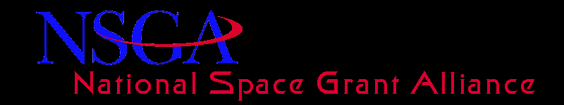
Alliance Board Teleconference – February 7, 2013
Participants
Alliance Board Members: John Gregory, Jaydeep Mukherjee, , Mary Sandy, Chris House, Cassandra Runyon, Jack Higginbotham, Toni Galvin, Gary Slater, Peter Schultz, Steve Ruffin, Angela Des Jardins and Yervant Terzian
Guests: Joe Danek (TIG), Carolyn Fuller (VSA)
Minutes of January 10, 2013 Telecon: John Gregory moved to approve the minutes, Yervant Terzian seconded the motion. All in favor
Update from Carolyn Fuller
Carolyn informed the Board that the budget will be delayed this year. She further added that sequestration is still on for March 1, 2013. She emphasized that the best strategy for the Hill visit is to have a simple message and talk about the continuation the program.
Hill talking points for FY 2013
  - Request Same level as CR
  - First fund states that have not been awarded their 4th year funding
  - Allocate remaining funds among existing consortia
Hill talking points for FY 2013
  - Ask $40 Million for FY2014
  - Authorization at existing level of $45Milion (For FY2014 onwards)
The Board accepted the talking points
Yervant Terzian gave an update on his meeting with Diane Detroye. He informed the Board that applicants for Program Manger’s position are being interviewed this week.
Draft of reauthorization language
Joe Danek mentioned that past reauthorization of NASA only had a statement about the amount of funds for Space Grant. It may be a problem to put extra language in the authorization.
Carolyn Fuller suggested that we keep very simple language and work with the Senate later for specific language.
Telecon adjourned at 4:10PM

