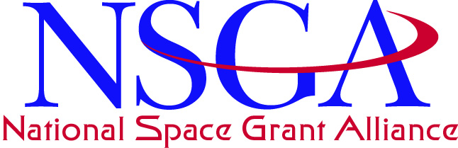

Pasadena, CA ∙ October 2004

BOARD AGENDA

- Board transactions since the July 2004 Board meeting in Ithaca, NY
  - Review of records finds one missing tax return, missing DC tax-exempt forms, and a very out of date registered agent agreement.
- Treasurer’s report – Majid Jaraiedi
- Review of authorization and appropriation status
- VSA/TIG Report- Joe Danek
- NASA admin cost and full cost accounting charges
- Workforce Development funding cut
- Half million deduction for a new summer NASA Center fellowship program
- Implications of a funding cut: Increased consortia admin percentage (to maintain infrastructure), reduced awards in all categories, reduction in outcome metrics of performance, etc.
- Necessity of keeping our requested language focused and easy to implement
- Charge to the ad hoc committee on planning
- Ad hoc committee on planning report – Pat Hynes
- Resolution to engage Bassel El-Kasaby on a pro bono basis for records audit and filing of forms in DC
- Targeted calls for action
- Nominations report

